A Cyber-Physical Inspection Assistant for Semi-Automated Dimensional Quality Control in Smart Manufacturing
Priyank Bhojak¹, Vatsal Shah², Vansh Malani³, Khushi Patel^{4*}
^{1,2} Department of Information Technology,
Birla Vishvakarma Mahavidhyala
Anand 388120, India

³Department of Computer Science and Engineering,
Devang Patel Institute of Advance Technology and Research (DEPSTAR),
Faculty of Technology and Engineering (FTE),
CHARUSAT Campus, Charotar University of Science and Technology (CHARUSAT)
Changa 388421, India;
Bvm.ac.in
Abstract. Most assembly-line dimensional inspections remain manual,
creating bottlenecks as industries transition toward Industry 4.0 practices. Small and medium-sized enterprises often lack affordable solutions
that digitize quality inspection without relying on expensive metrology
hardware or full automation. This paper presents a PC-based Inspection Assistant designed to support manual dimensional measurement using low-cost digital tools. The system captures real-time data from USB digital vernier calipers, guides
operators through step-by-step video-assisted workflows, and stores in-
spection results via a backend API connected to structured storage. A
timing-based input filtering method isolates measurement data while ig-
noring regular keyboard input.

Keywords: Zero Trust Architecture (ZTA); Distributed Firewalls (DFW); Identity and Access Management (IAM); Multi-Factor Authentication (MFA); Policy Enforcement Point (PEP); Single Packet Authorization (SPA); IoT Security; Edge Computing.
- Introduction
Cybercrime losses are projected to reach $10.6 trillion globally by 2025, with SMEs accounting for 43% of all attacks, yet only 14% report sufficient protection [1]. Ransomware, insider threats, and zero-day exploits are examples of advanced attacks that are becoming harder to stop with traditional perimeter-based protection systems. The increase of remote work and the widespread use of cloud computing have made the attack surface even bigger, which means that security needs to be more flexible and strong [2] [3] [4].
Zero Trust Architecture (ZTA) uses the "Never Trust, Always Verify" concept instead of perimeter-based trust. It uses continuous authentication, least privilege access, and micro-segmentation [5] [6] [7]. ZTA is good at blocking attacks that are based on identification, but it doesn't always do a good job of stopping threats that are based on the network layer, such as malware-infected endpoints, rogue traffic, and data exfiltration [5]. These concerns are most obvious in regions with a lot of different sorts of devices and networks that aren't connected to each other.
Distributed Firewalls (DFWs) also secure the network layer very well by enforcing security rules across multiple nodes and blocking assaults at the edge [8] [9]. But DFWs don't have built-in mechanisms to check a user's identity, so they aren't as good at blocking assaults that exploit credentials or threats from inside the company [6].
ZTA and DFWs have different but related problems. ZTA gives you a lot of control over your identification but not much visibility at the network layer. DFWs, on the other hand, let you filter traffic in a very specific way without knowing who you are or having to keep checking. Research that is already out there generally looks at them separately, which makes enforcement less effective. This work combines both to create a single policy enforcement system that links identification to authentication and traffic control across remote nodes.
The next section covers the background theory which includes an overview of the Zero-Trust architecture (ZTA), Distributed Firewall (DFW) and other security technologies used in the proposed system like Port Knocking, Single Packet Authentication (SPA), Identity and Access Management (IAM), and Software Defined Perimeter (SDP). Next section covers the proposed system design, which includes a layered security model, an implementation work-flow, and ways to enforce policies. The last section discusses the experimental evaluation, where we look at the performance, resilience, and security of the integrated solution and then compare it to other methods.
- Background Theory
Modern network defense needs identity assurance, adaptive access control, and continuous verification [7] [5]. A various technology such as Multi-Factor Authentication, Identity and Access Management, etc. which supports the layered protection approach are used in the proposed model.
Multi-Factor Authentication (MFA) makes identity verification stronger by demanding more than one independent credential before access is given. Keycloak handles MFA at the IAM layer in the suggested setup. This makes sure that only authenticated users may get authentication tokens [9]. Identification and Access Management (IAM) puts all of a user's identification, session handling, and permission decisions in one place. IAM connects each identity to network policies that are carried out by nftables rules on different nodes, along with the Policy Enforcement Point (PEP) and Policy Decision Point (PDP) [2].
Port knocking and single packet authorization (SPA) provide a layer of stealth to the network.These mechanisms reduce the attack surface before IAM authentication by keeping services closed until a valid cryptographic request is received [10] [11].
By enforcing context-aware network rules at endpoints, distributed firewalls (DFWs) provide for packet-level control that is in sync with user identities. The requirement that even authenticated users undergo traffic compliance checks is a local enforcement measure that supports the ZTA principle of continuous verification.
In order to isolate resources and prevent unwanted devices from even detecting protected services, Software-Defined Perimeter (SDP) ideas are used. By preventing unauthenticated individuals from seeing anything, this upholds the "Never Trust, Always Verify" principle [5]. When combined, these elements allow for a single, flexible policy framework that verifies user identity and network activity, providing fine-grained control over every node in the distributed system.

Table 1.1. The criteria-based comparison between the Distributed Firewalls and Zero Trust Architecture
Criteria | Distributed Firewalls (DFW) | Zero Trust Architecture (ZTA)
Primary Focus | Network-level security (Ingress/Egress filtering, traffic control). | Identity-based security with continuous verification.
Access Control | Rule-based filtering (IP, port, protocol). | Dynamic, policy-driven access based on user identity, device posture, and risk.
Authentication | No built-in authentication, relies on firewall rules. | Uses IAM, MFA, and Policy Enforcement Points (PEP) for authentication.
Device Trust Verification | Can block compromised devices based on predefined rules. | Continuously checks device trust before granting access.
Lateral Movement Prevention | Limits internal traffic using segmentation rules. | Uses micro-segmentation and identity verification to prevent lateral movement.
- Proposed Architecture
The proposed framework unifies Distributed Firewalls (DFWs) and Zero Trust Architecture (ZTA) into a layered, identity-aware defense that controls access by context [2] [12]. This integration makes it harder for insiders to attack, move laterally, or compromise devices.
At important chokepoints and endpoints, distributed firewalls that use nftables are used to check that devices are compliant and block traffic coming in and going out. Integrated open-source IDS tools such as Zeek perform signature- and anomaly-based inspection, ensuring malicious traffic is blocked before authentication and reducing exposure to compromised devices.
After network-layer validation, identity-layer security is enforced through Keycloak (IAM) using OpenID Connect and OAuth 2.0 for MFA and SSO. Policy Enforcement Points (PEPs) forward requests to Policy Decision Points (PDPs), which evaluate roles, device posture, and contextual factors before granting access.
Single Packet Authorization (SPA) adds a stealth layer by requiring a valid, cryptographically signed one-time packet before any service becomes visible, preventing unauthorized discovery and access.
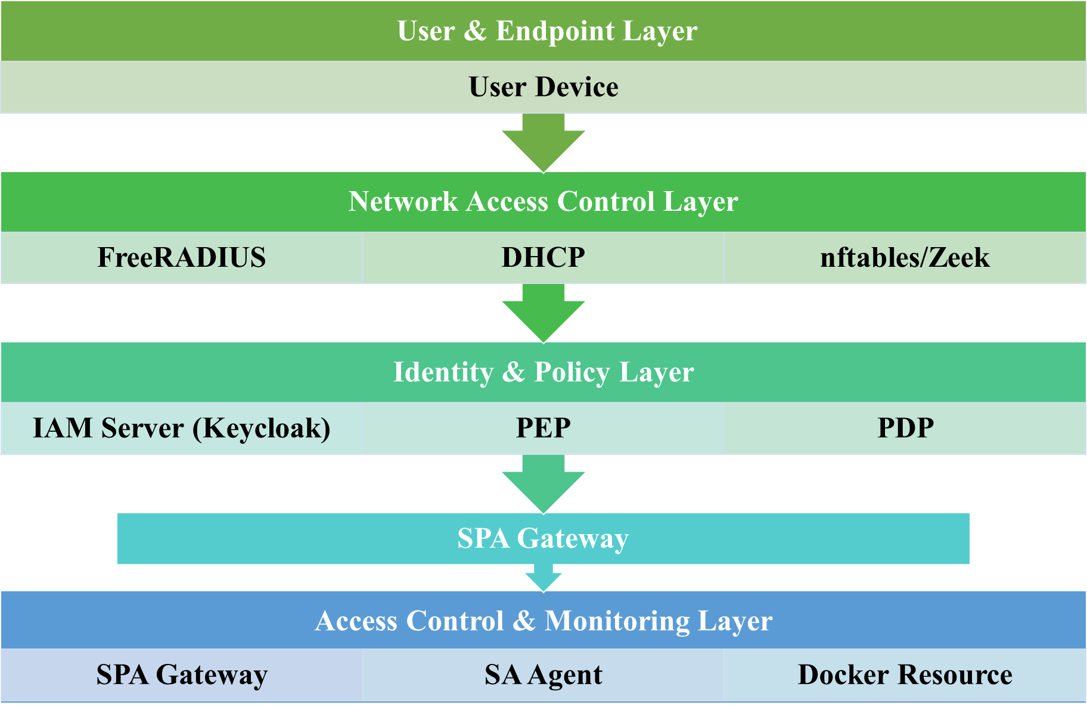
Fig. 1. Layered architecture of proposed system
The system also uses Situational Awareness (SA) agents to keep an eye on network activity and user behavior all the time. These agents look for changes in normal behavior and, if they find any, they can use the PEP to start dynamic re-authentication or revoke access, which enforces real-time Zero Trust principles. The layered architecture of proposed system is as shown in Fig.1.
This architecture supports a comprehensive security paradigm that combines contextual access control with network-based enforcement. This makes it possible to have scalable, fine-grained, and adaptive security that works well in modern dispersed contexts like the cloud, IoT, and edge deployments. Fig. 2 and Fig. 3 shows the working of proposed system.

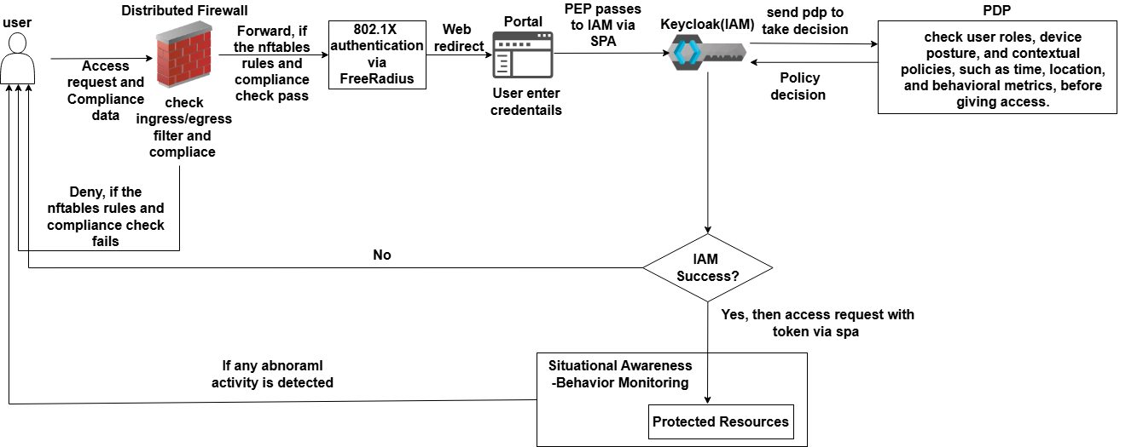
Fig. 2. Proposed Zero Trust Architecture (ZTA) with Distributed Firewall Integration
  - Comparative Analysis and Related Work
Few studies have tried to combine identity-aware and traffic-aware enforcement into a single framework, while many have looked at Distributed Firewalls (DFWs) or Zero Trust Architecture (ZTA) separately [2]. While authentication, authorization, and micro-segmentation are the main focuses of current ZTA implementations, they offer little insight into network-level activities and are unable to effectively identify or counteract traffic-based threats once access has been given. On the other hand, DFW models lack tools for ongoing identity verification and contextual access decisions, but they do impose granular traffic filtering across dispersed endpoints. [8].

Table 2.1. Summarizes representative approaches and highlights their functional limitations compared to the proposed integrated model.
Approach/References | Core Focus | Limitations | Proposed Framework Advantage
ZTA Models(references) | Identity-centric control using IAM, MFA, and micro segmentation | No enforcement at packet or flow level; lacks real-time device compliance | Adds nftables-based distributed filtering tied to user identity
DFW Architectures(references) | Distributed rule enforcement at endpoints | Absent user identity linkage; static rule sets | Integrates Keycloak and PEP for dynamic, identity aware rule updates
Collaborative Zero Trust Systems (references) | Multi agent ZTA orchestration | High resource demand, centralized dependency | Lightweight implementation using Raspberry Pi and modular services
Proposed ZTA + DFW | Unified identity network enforcement | Not applicable (proposed work) | Achieves 100 % packet filtering, 1.8 s authentication latency, and 30 % CPU usage on Raspberry Pi 4
- Result Analysis
  - Experimental Setup
The architecture is built using a Raspberry Pi 4 Model B with 8 GB RAM and 32GB storage. Tools like Docker and Apache2 are installed to host and manage services. The system is based on a layered flow that starts with network authentication and ends with role-based access control. For network access, the Pi uses its Ethernet port (eth0) as a DHCP server. Devices connecting to it must support the 802.1X protocol to get access to the network. FreeRADIUS is used for authentication, where users are validated using a username, password, and an additional secret. Only after this, access to the network is allowed.
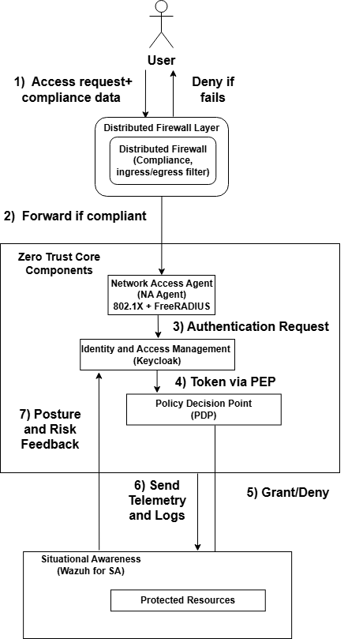
Fig. 3. Data Flow Diagram of the Proposed ZTA System
Once authenticated at the network level, the user is redirected to a web interface for login. Identity and access management, including multi-factor authentication, is handled using Keycloak, which is set up with its own realm. A Python-based PEP client interacts with Keycloak and sends the authentication token to the PEP server. The PEP server forwards the token and works together with the PDP to make access decisions based on the user's role and permissions. Port knocking is also integrated into the flow to add another layer of control. The protected resource is hosted separately in a Docker container and is only accessible after all checks are cleared. User activity is continuously monitored using Zeek and [11]Wazuh to maintain compliance and detect anomalies in real time. The Raspberry Pi handles the complete Zero Trust logic and distributed firewall rules within this setup.
  - Tools & Technologies
The table 3.1 shows the tools and technologies used for the implementation of proposed architecture.
Table 3.1. Tool / Technology used in the architecture with its defined purpose
Tool / Technology | Purpose in Architecture
Raspberry Pi 4 Model B (8GB, 32GB) | Acts as the central ZTA + distributed firewall node, running all services in a compact, low-power environment.
Docker | Hosts and manages isolated services (Keycloak, protected resources, supporting microservices) for modular and scalable deployment.
Apache2 | Serves the web interface for post-network authentication user login and management portal.
Ethernet Port (eth0) as DHCP Server | Provides IP allocation and initial network connectivity to endpoint devices.
802.1X Protocol | Enforces network access control by requiring endpoint devices to authenticate before receiving network access.
FreeRADIUS | Handles network-level authentication with username, password, and shared secret validation as part of NAC enforcement.
Keycloak (IAM) | Manages identity and access management, multi-factor authentication, and role-based access controls within a custom realm.
Python-based PEP Client | Interfaces with Keycloak to request tokens and with the PEP server for policy enforcement decisions.
PEP Server | Receives authentication tokens and enforces access policies by interacting with the PDP based on user roles and permissions.
PDP (Policy Decision Point) | Evaluates policies and returns allow/deny decisions for requested resources based on identity, context, and role data.
Port Knocking | Adds an additional security layer by requiring a specific knock sequence to open protected service ports.
Docker Container (Protected Resource) | Hosts critical resources that are only accessible after successful ZTA checks, maintaining isolation and control.
Zero Trust Logic and Distributed Firewall Rules | Managed within the Pi environment using nftables and scripts, ensuring both network-layer and identity-layer security enforcement.
Wazuh & Zeek | Provides centralized log monitoring, intrusion detection, and compliance auditing by collecting and analyzing security events from the Raspberry Pi and connected endpoints, enhancing visibility and aiding in anomaly detection within the Zero Trust and distributed firewall environment.
  - Performance Evaluation
We used a structured testing strategy to see how well the proposed Zero Trust Architecture and distributed firewall mechanisms worked on the Raspberry Pi 4 platform. The assessment concentrated on validating connection, authentication protocols, multi-factor authentication, token validation, real-time anomaly detection, and system performance under stress conditions.
Test Scenarios Executed:
- Network Connectivity: Devices connected via Ethernet are examined to see if the DHCP server could reliably allocate IP addresses and if FreeRADIUS could enforce 802.1X authentication.
- User Authentication and MFA: The system was checked to make sure that it could accurately check credentials. Keycloak controlled multi-factor authentication and made sure that tokens were given out after successful authentication.
- Token Handling: The PEP client is developed in python. It delivered authentication tokens to the PEP server. PEP server sent them to the PDP to check against different user roles and access rights.
- Anomaly Monitoring: Wazuh was used to monitor the logs to identify the unauthorized login attempts, and send notifications if malicious activity like repeated unsuccessful logins and network scans.
- Single Packet Authorization (SPA) and Port Knocking: We did controlled tests to see how well the system handled valid and incorrect port knock sequences and SPA challenges. This made sure that unauthorized attempts were blocked.
Boundary and Stress Testing:
- The architecture was subjected to up to 15 simultaneous device connections to observe CPU and memory usage during concurrent authentication and policy enforcement.
- Simulated high-volume HTTP/HTTPS requests tested the system's resilience and the nftables firewall’s handling of excessive traffic.
- Attempts to bypass 802.1X authentication using MAC spoofing techniques were consistently rejected, affirming network-layer defense reliability.
Table 3.2. Observations.
Metric | Observed Value
CPU Usage (Idle) | 6–8%
CPU Usage (Authentication Load) | 20–30%
RAM Usage (Idle) | ~450 MB
RAM Usage (Under Load) | ~950 MB
Authentication Latency (MFA + Token) | ~1.8 seconds
Packet Drop (Scan Simulation) | 100% blocked by nftables

Fig. 4. Authentication latency trend with increasing concurrent connections.
Table 3.3. Performance and scalability metrics under increasing concurrent connections, compared against acceptable thresholds for Raspberry Pi 4 hardware.
Number of Concurrent Connections | Average CPU Usage (%) | RAM Usage (in MBs) | Authentication Latency (s) | Acceptable Threshold
5 | 18 | 600 | 1.2 | CPU ≤ 40 %, RAM ≤ 1.5 GB, Latency ≤ 2 s
10 | 25 | 800 | 1.5 | CPU ≤ 40 %, RAM ≤ 1.5 GB, Latency ≤ 2 s
15 | 30 | 950 | 1.8 | CPU ≤ 40 %, RAM ≤ 1.5 GB, Latency ≤ 2 s
Configuration Highlights:
- nftables Rule Example: ip protocol tcp ct state new tcp dport {80, 443} accept to allow HTTP/HTTPS while filtering other traffic.
- FreeRADIUS Setup Note: eap.conf configured for EAP-TTLS with PEAP as the inner authentication method for simplified testing.
The results in Table 3.3 show that performance scales linearly across all parameters. CPU and memory utilization is well under the limits of the Raspberry Pi 4, and authentication delay stays below 2 seconds. These measurements confirm that the proposed ZTA + DFW framework can handle a lot of traffic and is stable when used at the same time [8].
Key Findings:
The system did a good job of enforcing multilayer security standards, keeping authentication processes safe and stopping unauthorized devices from connecting to the network. There were tiny delays in authenticating (~1.8 seconds) when using layered checks like MFA and SPA, but these were still acceptable for labs and small-scale environments. The Raspberry Pi 4 was able to handle the resource utilization, showing that low-power devices may work well with layered Zero Trust implementations. Wazuh's ability to monitor in real time found and identified strange activity, which helped with compliance and gave a clear picture of what was happening on the network.The method showed a strong, scalable way to layer network security that fit with the goals of keeping resources safe while keeping operations running smoothly within set performance limits.
  - Result & Analysis
The Raspberry Pi 4-based Zero Trust Architecture (ZTA) works with a distributed firewall system to provide a layered security environment that enforces stringent access control from network connection to resource access. At first, devices must use FreeRADIUS to authenticate through 802.1X. This makes sure that only devices that follow the rules and have valid credentials get IP addresses and basic network access. Once connected, users go to a web portal controlled by IAM and managed by Keycloak, where they can use multi-factor authentication and role validation. The PEP client sends secure tokens, and the PEP server uses the PDP to set up detailed, context-based access rules. Port knocking adds another degree of security before resources are made available. Docker containers keep services separate, making sure that resources are only available once all checks have been passed. During this operation, nftables makes sure that ingress and egress filtering is in place to block traffic that is not authorized or is suspect. This architecture makes sure that unauthorized device connections are found and stopped as soon as possible. It also stops lateral movement and keeps resource segmentation while running well on low-resource hardware. This shows that it is a practical, scalable Zero Trust and network-layer security solution for businesses and schools.
  - Limitations
- Resource Constraints. Raspberry Pi hardware limitations may affect performance under heavy load or high concurrent user sessions.
- Network Latency. Layered checks (802.1X, IAM, PEP, SPA) can introduce latency in authentication and access provisioning [3].
- Management Overhead. Maintaining nftables rules, IAM configurations, and Docker services requires ongoing administrative effort [9] [14].
- Limited Advanced Threat Detection. Without integrated advanced ML or threat intelligence feeds, detection is limited to rule and signature-based systems.
- Scalability Challenges. Scaling to large enterprise environments may require additional hardware and orchestration layers beyond a single Pi node [3].
- Single Point of Failure. A single Pi acting as the enforcement point creates a potential single point of failure without HA replication.

There are still a number of operational limitations even though the architecture successfully implements distributed Zero Trust principles [5]. Future versions may use dynamic load distribution or lightweight clustering to alleviate possible resource bottlenecks on Raspberry Pi nodes [8]. Token caching and local decision caching at edge nodes can help minimize the network latency caused by multi-stage authentication. A backup IAM-PEP pair or a replicated policy database synchronized via incremental snapshots can be used to add redundancy and combat the primary controller's single point of failure. In addition to reducing management overhead, regular log pruning and rule optimization help preserve policy uniformity among nodes.
  - Security Evaluation and Threat Model
To evaluate the resilience of the proposed ZTA + DFW framework, a qualitative threat model was developed that identifies key attack vectors across network, identity, and application layers [5]. Table 3.4 summarizes these threats, associated risks, and corresponding mitigation mechanisms implemented within the framework [7].

Discussion:
Layered defense across user identity, network traffic, and service exposure is ensured by distributed enforcement in conjunction with ZTA principles [5]. The distributed design, in contrast to centralized models, inhibits global rule manipulation and limits the impact of a hacked node [8]. Several security agents (PEP, IAM, and DFW nodes) check authentication, authorization, and policy propagation on their own to protect against spoofing and privilege misuse [13].
Zeek and Wazuh's periodic anomaly detection makes it much easier to understand what's going on by comparing logs from various endpoints. This lets the system find rules infractions or DDoS-like activities practically right away.
The study shows that the suggested method keeps operations running smoothly and performance stable while also providing significant protection against volumetric attacks, insider abuse, and identity theft.
Table 3.4. Threat model and mitigation summary for the proposed ZTA + DFW framework.
Threat Type | Attack Vector / Scenario | Mitigation Mechanism | Evaluation Outcome
Insider Attack | Authenticated users attempting unauthorized lateral movement or privilege escalation | Role-based access control (RBAC) via Keycloak IAM; continuous session validation; distributed firewall rules restrict inter-node traffic | Unauthorized lateral movement blocked; access denied beyond assigned roles
Spoofing / Identity Impersonation | Attackers spoofing device MAC/IP or credentials to gain network entry | 802.1X with FreeRADIUS for device authentication; MFA and token validation through Keycloak; device-ID mapping in nftables | Spoofed devices rejected; authentication requests without valid tokens denied
Denial of Service (DoS/DDoS) | Excessive requests to overload authentication or service endpoints | nftables rate limiting; connection thresholds; Zeek-based anomaly detection | Requests beyond threshold dropped; legitimate sessions unaffected
Port Scanning / Reconnaissance | External entities scanning for open services | Port knocking and Single Packet Authorization (SPA) | All unauthorized scan attempts dropped and no open port visibility.
Compromised Endpoint | Infected or policy-violating nodes within network | Distributed nftables policies with Zeek + Wazuh monitoring for anomaly triggers | Suspicious nodes isolated; firewall rules updated dynamically
  - Policy Update and Synchronization
All distributed firewall nodes must have uniform policy enforcement in order to maintain a consistent security posture. Each Policy Enforcement Point (PEP) in the proposed system interacts with the central IAM and Policy Decision Point (PDP) to obtain updated access control rules and identity mappings [2]. To synchronize policies, version-controlled update messages are transmitted via a secure API channel.
To keep a consistent security posture, all firewall nodes that are spread out must implement the same policies. The proposed system has a central IAM and Policy Decision Point (PDP) that each Policy Enforcement Point (PEP) talks to in order to get new access control rules and identity mappings [3]. To make sure that rules are in sync, version-controlled update messages are sent using a secure API channel.
To stop configuration drift or unwanted rule insertion [13]., each DFW node checks the policy's signature and timestamp before making modifications. PEP and IAM send heartbeat signals to each other on a regular basis. If a policy is corrupted or out of date, it will immediately roll back to the most recent validated state.
This distributed updating method makes it possible to send nftables rules in real time when the context changes, such as when a device posture changes, an anomaly detection alert goes off, or a user logs out. Because of this, the system keeps all nodes consistent while cutting down on downtime and administrative work [8].
- Future Enhancements
- Finding anomalies via machine learning. Combine lightweight ML models with Zeek logs to find and fix behavioral problems as they happen.
- Policy Engine Automation. Make a self-adaptive policy engine that can change nftables and IAM policies on the fly based on traffic and threat intelligence.
- Orchestration of containers. Move Docker containers to Kubernetes to handle scaling, service isolation, and automatic recovery.
- Better logging and forensics. Use ELK/Graylog to combine all of your logs into one place so you can monitor them in real time and be ready for forensic work.
- Adaptation to the cloud. Add support for hybrid and cloud-native deployments to the architecture while keeping Zero Trust enforcement and distributed firewall features.
- AI-Driven Anomaly Detection. Integrate machine learning models trained on Zeek and Wazuh telemetry to automatically detect deviations in user or network behavior. The AI engine would trigger adaptive rule updates, enabling predictive defense against evolving threats.
- Policy Orchestration and Automation. Extend the distributed control layer using container orchestration tools (e.g., Kubernetes or Docker Swarm) to enable seamless policy deployment, auto-scaling, and recovery of DFW nodes. This would improve resilience and simplify management in large-scale or hybrid-cloud environments.
- Hardware Security Integration. Utilize TPM modules on Raspberry Pi for device attestation and cryptographic key protection, strengthening hardware trust anchors
- Key Findings and Conclusion
Table 5.1. Summary of the comparative characteristics of traditional ZTA, standalone DFW, and the proposed unified model
Criteria / Feature | Traditional ZTA | Distributed Firewall (DFW) | Proposed ZTA + DFW Framework
Primary Focus | Identity-based access control and authentication | Network-layer traffic filtering and segmentation | Unified identity and traffic-level enforcement
Authentication Mechanism | IAM, MFA, continuous verification | Rule-based; no identity validation | Centralized IAM with MFA and token-based enforcement
Network-Layer Control | Limited; dependent on centralized gateways | Strong; per-node filtering | Integrated with identity-aware policy propagation
Policy Management | Centralized; static updates | Localized; manual configuration | Distributed version-controlled synchronization
Attack Surface | Reduced for identity attacks but exposed to rogue traffic | Reduced for network threats but exposed to credential misuse | Minimized; layered identity + network validation
Scalability | Moderate (controller load) | High (decentralized rules) | High (lightweight nodes with centralized coordination)
Performance Metrics | Latency ~3.2 s | N/A | Latency 1.8 s, CPU < 30 %, RAM < 1 GB
Deployment Suitability | Enterprise networks with strong IAM | Edge or IoT networks with packet filtering needs | IoT, edge, and small enterprises requiring unified Zero Trust enforcement

  - Practical Deployment and Scalability Discussion
The feasibility of real-world deployment is taken into consideration when designing the suggested ZTA + DFW framework. Lightweight nodes may be easily replicated across edge, IoT, or small-business networks thanks to its modular design, which eliminates the need for complex infrastructure. Essential services like Keycloak (IAM), nftables (DFW), and monitoring agents are run on each node in Docker containers, allowing for repeatable and portable installations on low-end hardware like the Raspberry Pi.
To manage distributed firewall clusters and keep synchronization with the central IAM during enterprise-scale rollouts, the framework can interface with container orchestration platforms such as Kubernetes or Docker Swarm. The secure policy API supports automatic deployment and reversal of rule updates and guarantees version consistency over hundreds of endpoints.
Lightweight clustering and selective policy caching at edge devices help IoT installations deal with restricted resources by lowering authentication latency and network reliance on the controller. Because of its versatility, the architecture can be used for research testbeds, campus networks, and industrial IoT segments that need constant verification without sacrificing resource efficiency.
  - Conclusion
This research demonstrates the effective integration of Zero Trust Architecture (ZTA) with distributed firewall mechanisms on a lightweight and cost-efficient Raspberry Pi platform, offering a layered and adaptive security framework. By combining 802.1X-based device compliance (via FreeRADIUS) and identity-aware access control (via Keycloak), the system ensures that only authenticated and contextually verified users gain access to protected network re-sources. The incorporation of nftables, port knocking, and Docker-based isolation further fortifies the network perimeter while limiting lateral movement and minimizing the attack surface.
The use of Raspberry Pi enables low-power, resource-efficient deployment, mak-ing the architecture particularly suitable for educational labs, IoT environments, and small-scale enterprises aiming to implement practical Zero Trust principles without high infrastructure overhead. Furthermore, the integration of real-time monitoring through Wazuh adds a proactive threat detection and compliance layer, enhancing the system’s responsiveness to emerging anomalies and attacks.
Overall, the proposed architecture offers a scalable, modular, and cost-effective solution for enforcing Zero Trust policies in decentralized environments, bridg-ing the gap between theoretical security models and real-world implementation needs.

Acknowledgement: This research is financially supported by Charotar University of Science and Technology (CHARUSAT).

References
- S. Morgan, "Cybercrime To Cost The World $10.5 Trillion Annually By 2025," in Cybercrime Magazine, 2020.
- R. Pellreddy, "Enhancing Endpoint Security through Collaborative Zero-Trust Integration: A Multi-Agent Approach," International Journal of Computer Trends and Technology, vol. 72, no. 10.14445/22312803/IJCTT-V72I8P112, pp. 86-90, 2024.
- T. U. a. A. I. S. Teerakanok, "Migrating to Zero Trust Architecture: Reviews and Challenges," Security and Communication Networks, no. 9947347, 2021.
- V. Pandya, A. Saiyed and a. K. Patel., "Recent Advancement in Fine-Grained Access Control and Secure Data Sharing Scheme for Distributed Environment," in Emerging Technologies for Computing, Communication and Smart Cities: Proceedings of ETCCS 2021, 2022.
- C. Buck, C. Olenberger, A. Schweizer, F. Völter and T. Eymann, "Never trust, always verify: A multivocal literature review on current knowledge and research gaps of zero-trust," Computer & Security, vol. 110, no. 102436, 2021.
- X. &. W. H. Yan, Survey on Zero-Trust Network Security, Singapore, 2020.
- A. a. G. P. Gupta, U. P. Pandey, P. Kushwaha, B. P. Lohani and K. Bhati, "ZTSA: Zero Trust Security Architecture a Comprehensive Survey," in 2024 International Conference on Communication, Computer Sciences and Engineering (IC3SE), 2024.
- N. T. K. G. A. K. W. J. a. D. L. A. Allami, "Oblivious and distributed firewall policies for securing firewalls from malicious attacks," Computer & Securiy, vol. 150, no. 10421, 2025.
- A.-D. a. B. D. G. a. P. a. A. D. Tudosi, "Secure network architecture based on distributed firewalls," in International Conference on Development and Application Systems (DAS), 2022.
- M. R. a. B. Stowers, "Single Packet Authorization (SPA)," in Black Hat USA, 2005.
- M. Krzywinski, "Port Knocking: Network Authentication Across Closed Ports," SysAdmin Magazine, vol. 12, no. 6, pp. 12-17, 2003.
- Q. S. a. Y. Shen, "Endpoint security reinforcement via integrated zero-trust systems," Computer & Security, vol. 136, no. 103537, 2024.
- N. B. S. B. Y. a. A. Bouhoula, "Automatic Conformance Verification of Distributed Firewalls to Security Requirements," 2021.
- K. a. C. R. a. K. K. A. Lubna, "Firewall log analysis and dynamic rule re-ordering in firewall policy anomaly management framework," in 2013 International Conference on Green Computing, Communication and Conservation of Energy (ICGCE), 2013.
- A.-D. a. G. A. a. B. D. G. a. P. a. A. D. Tudosi, "Design and Implementation of a Distributed Firewall Management System for Improved Security," in 22nd RoEduNet Conference: Networking in Education and Research (RoEduNet), 2023.
- D. S. F. C. A. Squicciarini, "A Survey on Identity and Access Management," Foundations and Trends in Privacy and Security, vol. 3, no. 4, pp. 280-410, 2021.

